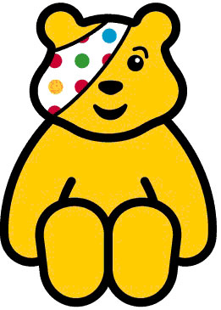

BBC CHILDREN IN NEED SPECIAL – Your ‘Children’s Favourites’
Puffin Billy - The Melodilight Orchestra conducted by Hubert Clifford
Making Memories - Frankie Laine
Teddy Bears picnic - Henry Hall and The BBC Dance Orchestra with Val Rosing vocal
Don't get around much anymore - Edward Woodward arranged & conducted by Johnny Arthey
Animal Crackers In My Soup - Shirley Temple
Matchstalk Men & Matchstalk Cast and Dogs - Ken Dodd
Yesterdays Dreams - Flanagan & Allen
More than ever now - Vince Hill Arranged and Conducted by Harry Robinson
Dance Gypsy Dance - David Whitfield
Little man you've had a busy day - Roy Fox Orchestra with Denny Dennis
I won't send Roses - Robert Preston
Devil’s Gallop - Charles Williams & his concert orchestra
On the street where you live - Ray Conniff his Orchestra & Chorus
Nymphs & Shepheards - Manchester Children’s Choir with the Halle Orchestra conducted by Hamilton Hardy
Once in love with Amy - Norman Wisdom with Norrie Paramor's Orchestra and Chorus
Morningtown Ride - The Seekers With Bobby Richards And His Orchestra
Unforgettable - Nat King Cole arranged & conducted by Nelson Riddle
You’re a pink toothbrush - Max Bygraves directed by Eric Rogers
The Sweetest music this side of heaven - Maurice Winnick & His Orchestra
In The Middle of the house - Alma Cogan
I'm stepping out with a memory tonight - The Jimmy Dorsey Orchestra with Helen O'Connell vocal
Big Rock Candy Mountain - Burl Ives
I'll take you home again Kathleen - Joseph Locke with Orchestra conducted by Noel Kelehan
With a song in my heart - Andre Kostelanetz And His Orchestra
Poor little rich girl - Bobby Sherwood Orchestra
The three billy goats gruff - Henry Cooper
You're my everything - Carmen Cavallaro with orchestra directed by Morris Stoloff
A windmill in old Amsterdam - Ronnie Hilton
The song of the Rose - Monte Rey with orchestra conducted by Philip Green
Three little fishes - Frankie Howerd
The Runaway Train - Michael Holiday
Lady Day - Frank Sinatra with Don Costa
Dicky Bird Hop - Gracie Fields with orchestra conducted by Ben Frankel
Up the wooden hill to Befordshire - Elsie Carlisle with Orchestra
Wedding of the Painted Doll - Russ Conway with Geoff Love
A walk in the Black Forrest - Horst Jankowski and His Orchestra

